So, let's get back to our debugging session again the next option you see is the display list option and that's Control+F12.

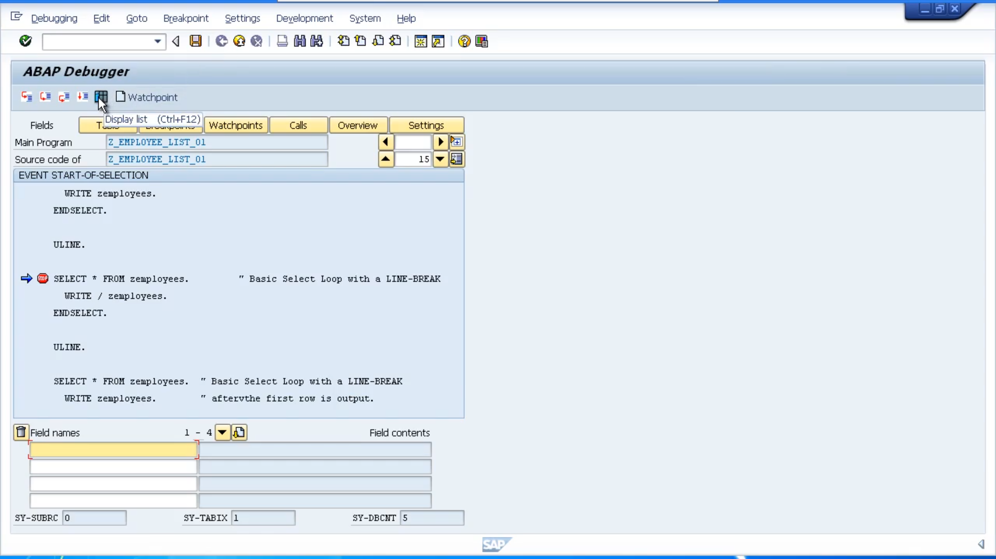

If we press this button, you can see it takes us to the output screen as it currently stands within our debug session. So, at the moment we have executed the code to output the results of the first select statements in our program.

We can press the F3 key to go back to the code. And if we start to execute some more lines, and press it again, [SOUND] we can see it outputs another two lines. So, it allows you to go see the results of your reports whilst the program is in midflow.

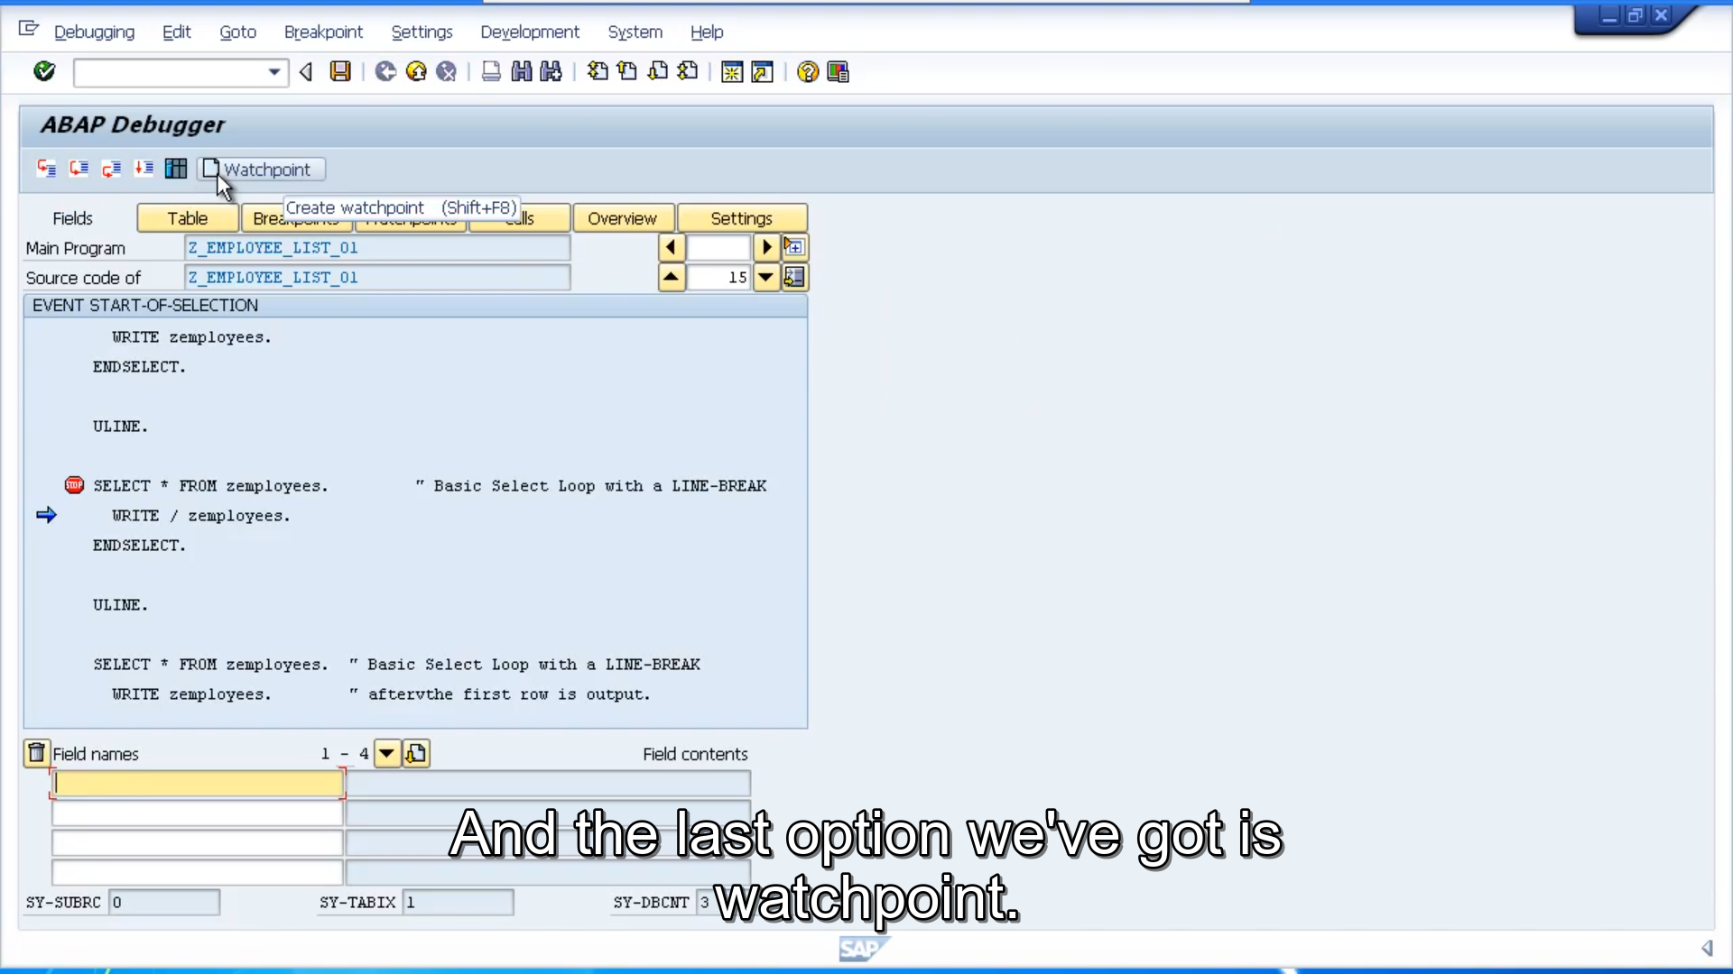And the last option we've got is watchpoint. And we will come to watchpoint just in a little while.

Now the fields mode of our app debugger allows us to check and modify the contents of the fields as we're debugging our program. You can double click on the field itself in the code section of the screen, or type in the field name in the lower section of the screen. So, for example, if I navigate to a place in the code where we're dealing with individual fields.

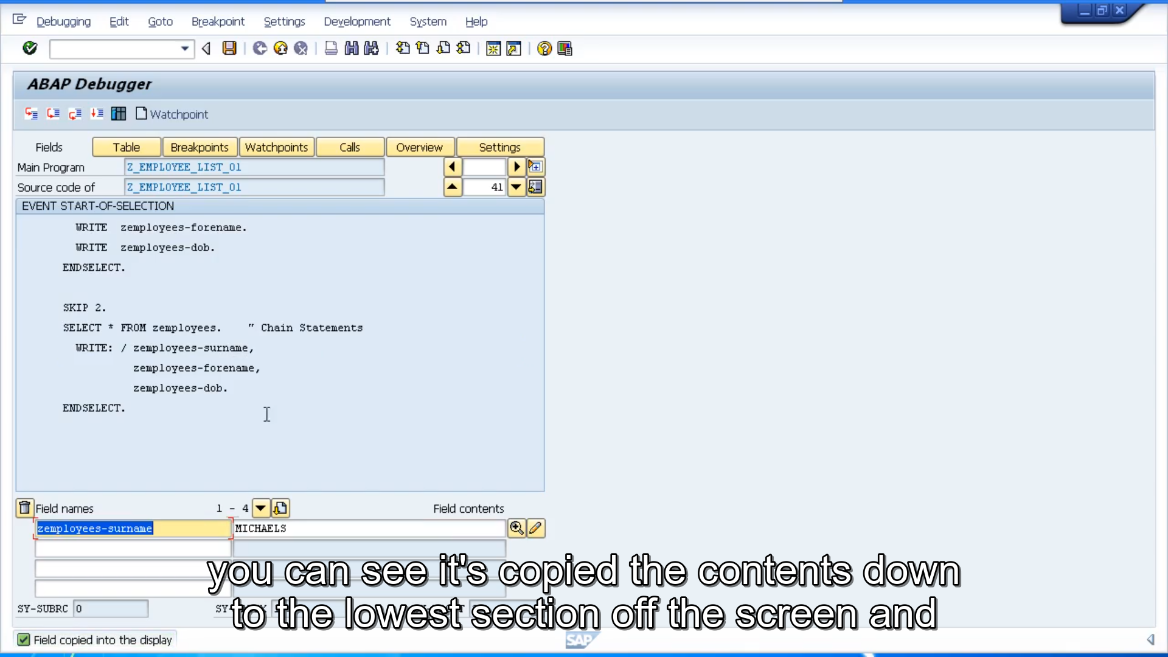I can double click on the field, and you can see it's copied the contents down to the lowest section off the screen and it shows the actual field name with the field content alternatively.

I can type the name or in my case because I don't like pressing too many keys I'll copy and paste the name into the lower section of the screen. And press Enter. You can see it has exactly the same effect.

And just to note, because I'm dealing with a table here, I have to qualify the field name with the table name first. So, it's table name dash field name whichever method you choose, the field name will always be on the left-hand side of this grid, and the contents will be displayed on the right-hand side. And this allows you to continue debugging your program, and watching the contents of the field that you have specified in the field names list. So, if I do a single step, we're going through our code line by line, and then the next select statement, we should see a change of surname and forename. There we go. So now it's changed to Brenda Nichols. I'll do it again. Execute the select and there we have a new employee coming in.

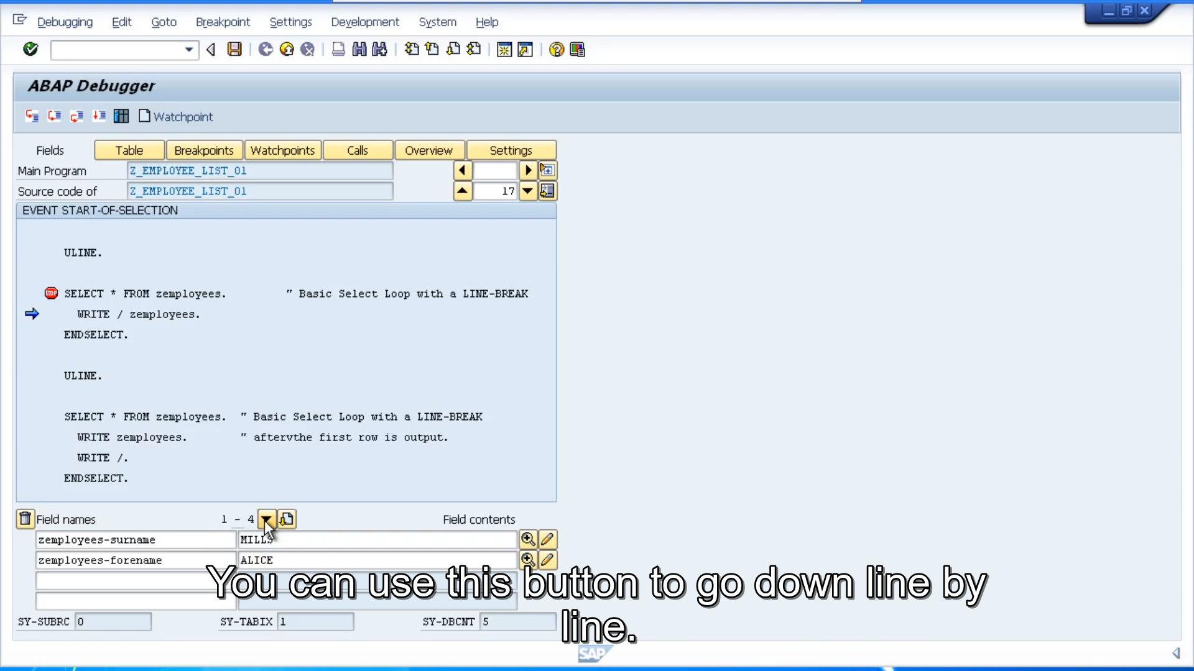

You'll notice there are only four rows available here but you can actually monitor below that amount. You can use this button to go down line by line.

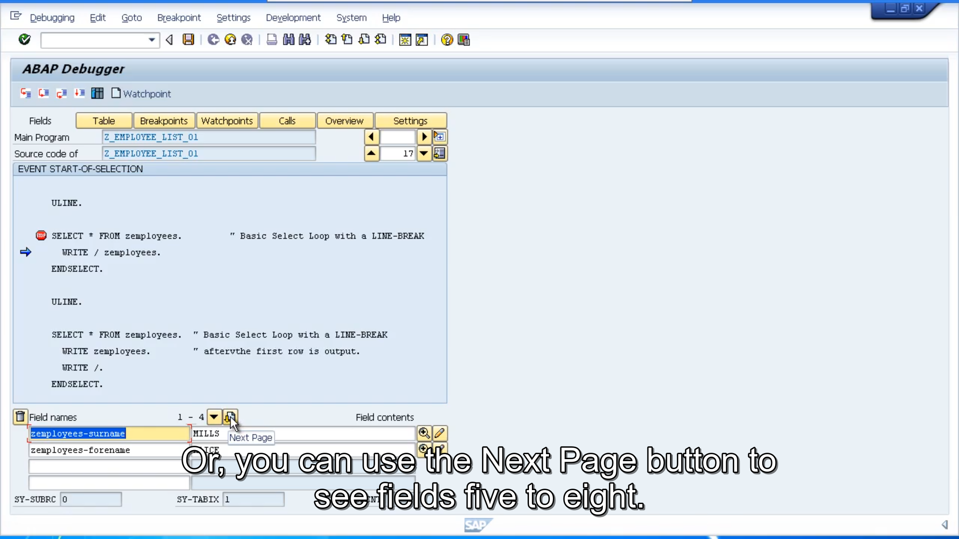Or, you can use the Next Page button to see fields five to eight. And, quite often, when you're debugging a program, you'll want to manually change the contents of a field. And, you can do this by clicking on the field in question, in this case surname.

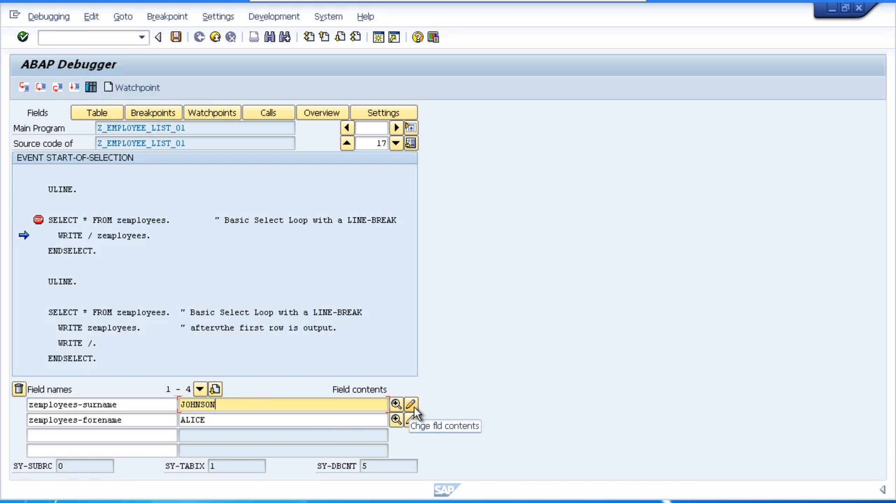Typing in your new value, and then click this change button. Now the contents of the surname field have been changed to Johnson. This is very useful when you're debugging your program because it saves you a lot of time. Quite often you don't want to come out of your debugging session, enter some new values in a variable, go back into your debugging session again, and pick up where you left off. This function allows you to change the contents of the field so, you can dynamically check the logic within your program using whatever values you like.